

**Lab No. 11**

Mehran University of Engineering and Technology Shaheed Zulfiquar Ali Bhutto Campus, Khairpur Mir’s Department of Software Engineering

**Course: Operating System SW-225 (Practical) - Instructor: Engr. Shamshad Naveed**

Objective: Familiarization with some of the most frequently used Linux commands

|  |  |  |  |  |
| --- | --- | --- | --- | --- |
| **Name:** | **Mohammad Saleem** | **Roll Number:** | | **K20SW033** |
| **Score:** | **Signature:** | **Date:** | **21-10-2022** | |

|  |  |  |  |  |  |  |  |
| --- | --- | --- | --- | --- | --- | --- | --- |
| **LAB PERFORMANCE INDICATOR** | SUBJECT KNOWLEDGE | DATA ANALYSIS AND INTERPRETATION | ABILITY TO CONDUCT EXPERIMENT | PRESENTATION | CALCULATION AND CODING | OBSERVATION  /RESULTS | SCORE |
|  |  |  |  |  |  |  |  |

Exercise

**Task:** Familiarization with some of the most frequently used Linux commands

# Answer:

* **“Pwd”**

It tells us what our current or present working directory is.

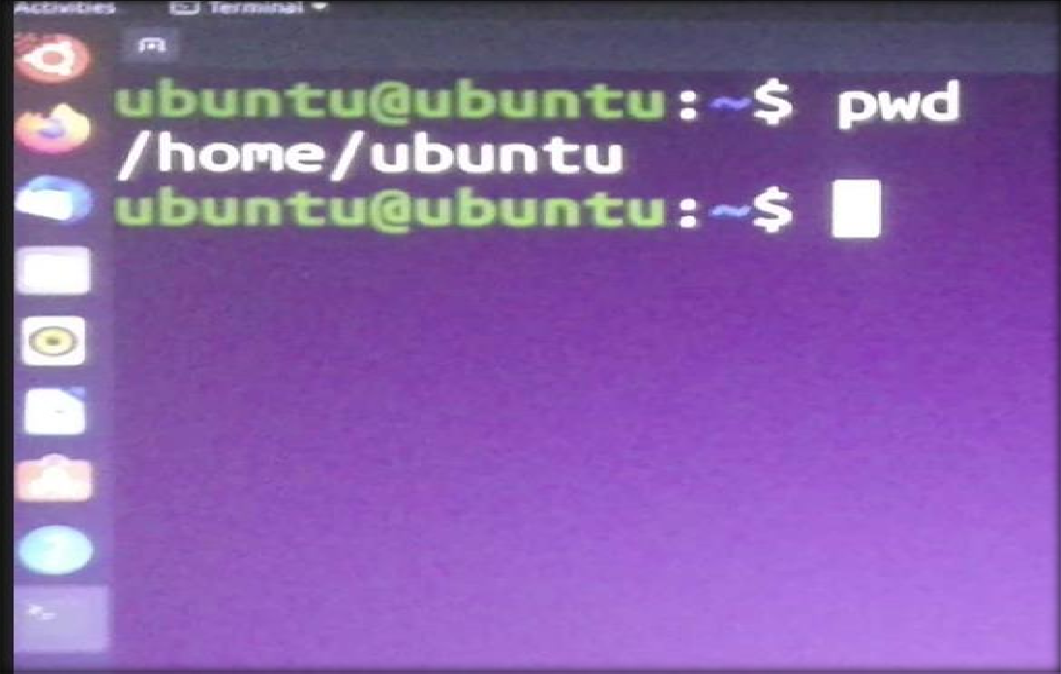

# “ls”

It shows lists files from the location

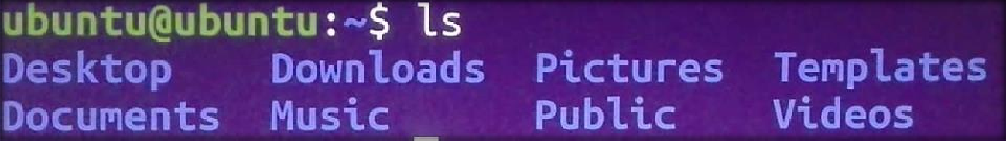

# “ls –a”

It lists all files including hidden file starting with ‘.’

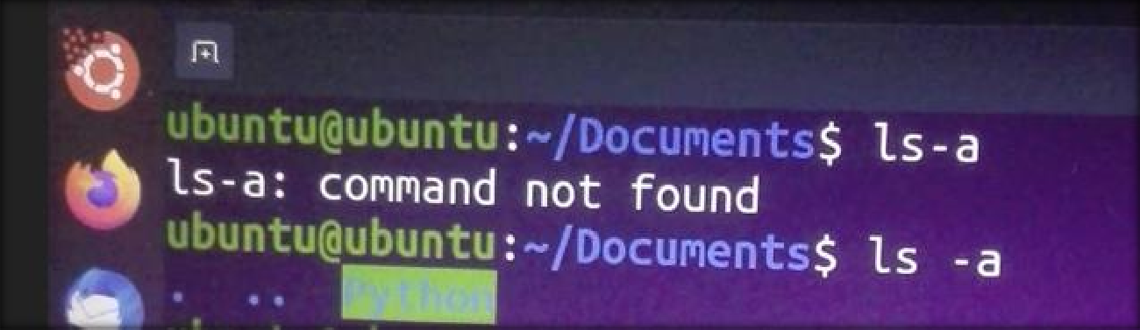

# “ls -l”

It lists with long format – show permissions

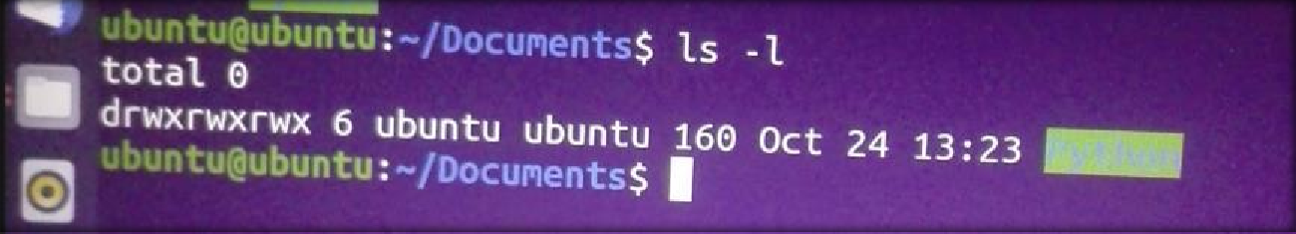

# “ls -r”

It list in reverse order

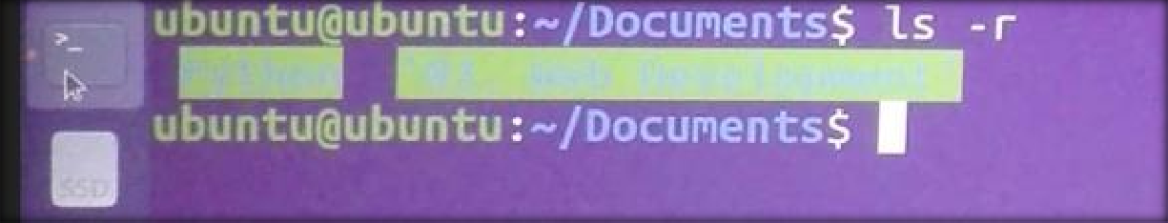

# “help”

It helps command just displays information about shell buily-in commands

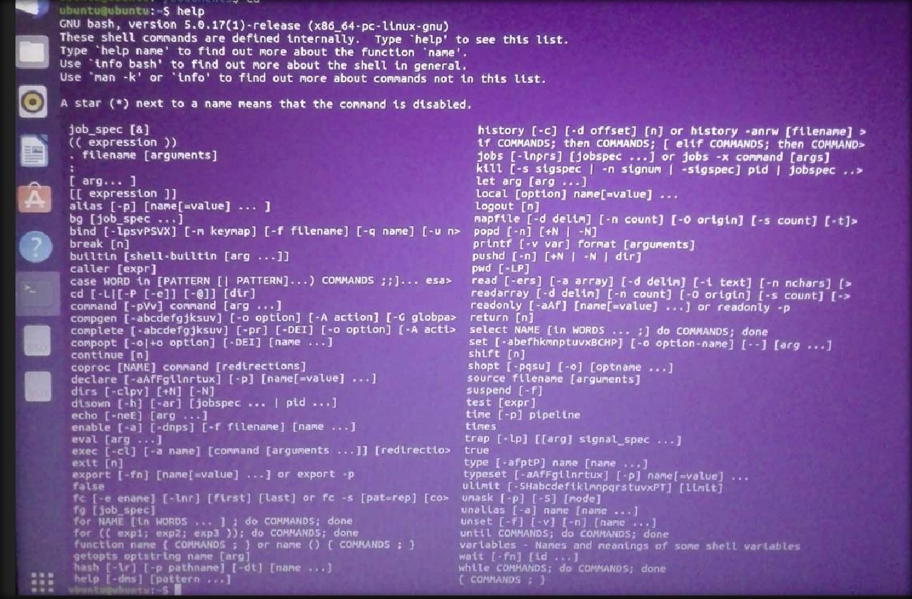

# “whoami”

It displays the username of the current user

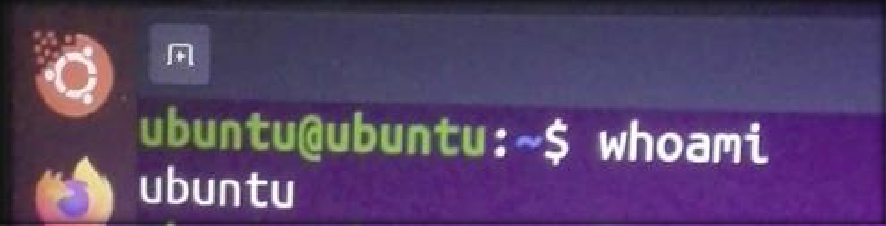

# “Date”

The simple “date” command displays the current date and time (including the day of the week, month, time, time zone, year).

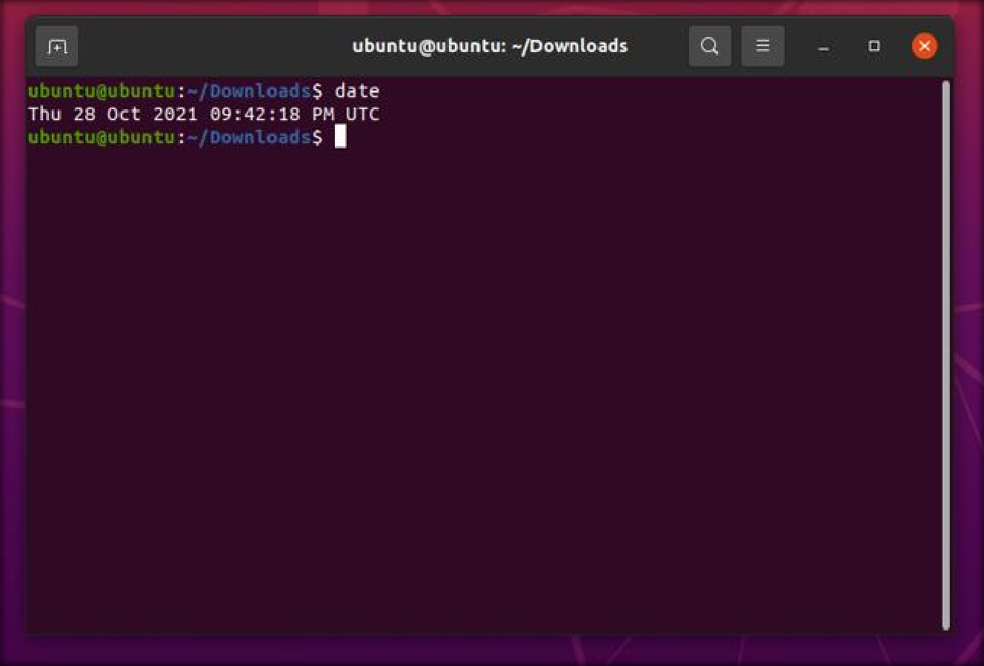

* **PS:** The command “PS” which is also known as process status [command](http://www.linfo.org/command.html) is used to provide information about the processes currently running on the system, including their respective process identification numbers (PIDs).

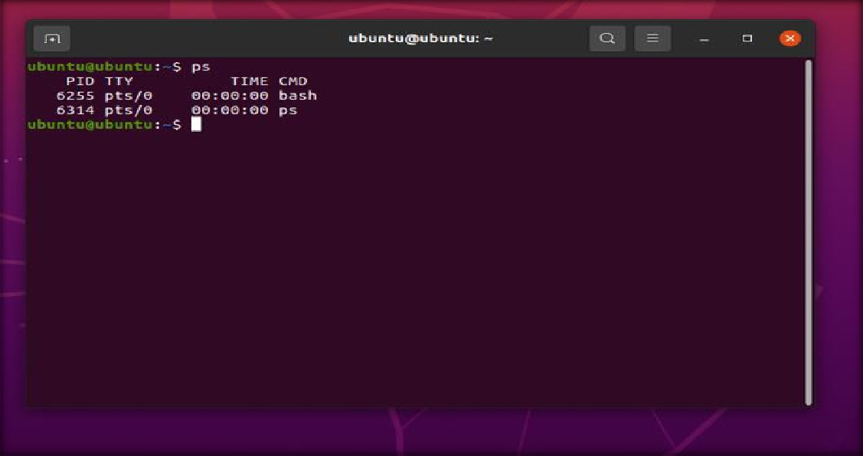

* **History:** The simple command “history” displays the list of all commands entered since the user started the session.

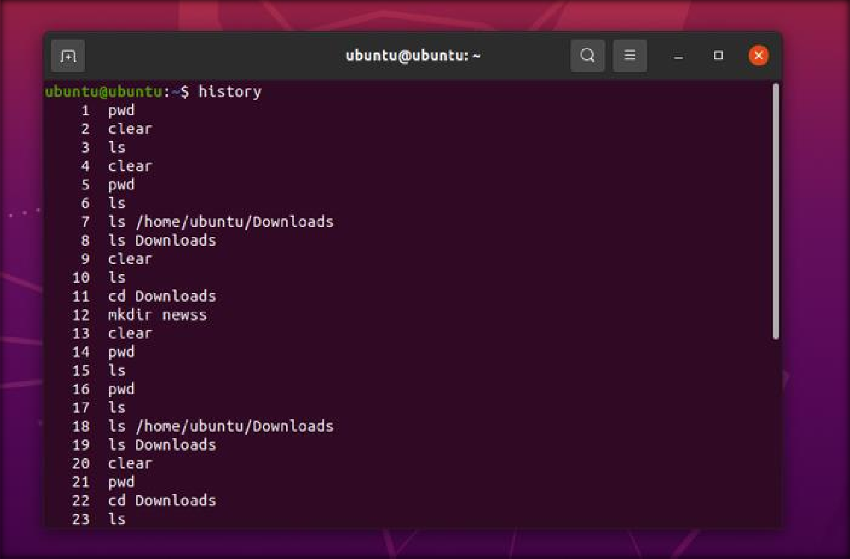

* **Uptime:** The command “uptime” provides information about how long the system has been running in one line. Result for this command includes the current time, the time duration system has been running for, the number of users who are currently logged on, and the system load averages for the past 1, 5, and 15 minutes.

